HIGHER NATIONALS - ASSESSMENT (ASSIGNMENT)

Course Title: | Pearson Higher Nationals in Computing
Name of the Learner: | Mr. / Ms.
Ref. No. of the Learner: |  | Pearson Regd. No.:
Unit No. & Title: | Unit 19: Data Structures & Algorithms | Batch No. & Semester: |  | CSD 7&8, Semester 04
Assignment Parts: | 01, 02, 03, 04 | Name of  Assessor: | Eng. A. L. Jubailah Begum
Issued Date: | 01 March 2021
Submission Date: | 10 April 2021 | Date Received 1st submission:
Re-submission Date: |  | Date Received 2nd submission:

Assessor Summative Feedback:

Grade: | Assessor Signature: | Date:
Resubmission Feedback - Formative:
Grade: | Assessor Signature: | Date:
Internal Verifier’s Comments:
Signature of the IV: |  | Date:
Student Agreement:  I understand the feedback given to me and agree to carry out the actions in future works as required and indicated. |  | Student Signature:
 |  | Date:

Please note that grade decisions are provisional. They are only confirmed once internal and external moderation has taken place and grades decisions have been agreed at the assessment board.

Learner Assessment Submission and Declaration

When submitting evidence for assessment, each learner must sign a declaration confirming that the work is their own.

Please list the evidence submitted for each task. Indicate the page numbers where the evidence can be found or describe the nature of the evidence (e.g. video, illustration).

Unit No. & Title:
Task | Assessment Evidence | P | Page No. | M | Page No. | D | Page No.

Additional comments to the Assessor:

Plagiarism

Plagiarism is a particular form of cheating. Plagiarism must be avoided at all costs and students who break the rules, however innocently, may be penalised. It is your responsibility to ensure that you understand correct referencing practices. As a university level student, you are expected to use appropriate references throughout and keep carefully detailed notes of all your sources of materials for material you have used in your work, including any material downloaded from the Internet. Please consult the relevant unit lecturer or your course tutor if you need any further advice.

Learner declaration

I certify that the work submitted for this assignment is my own. I have clearly referenced any sources used in the work. I understand that false declaration is a form of malpractice.

Learner Signature: Date:

Assessment Tracking

Assessment Record And Feedback Sheet
Programme: | HND Computing | Student Name:
Unit No. & Title: | Unit 19: Data Structures & Algorithms | Assessment Date: |  | Unit Grade:
Assessor Name: | Eng. A.L. Jubailah Begum | Completion Date: |  | IV Signature:

Assignment (Parts) | Learning Objectives | Criteria Targeted | Date Issued | Hand In Date | Formative  Feedback | Resubmission Date*
01 | LO1 Examine abstract data types, concrete data structures and algorithms | P1, P2  M1, M2  D1
02 | LO2 Specify abstract data types and algorithms in a  formal notation | P3  M3  D2
03 | LO3 Implement complex data structures and  algorithms | P4, P5  M4  D3
04 | LO4 Assess the effectiveness of data structures and  algorithms | P6, P7  M5  D4

Assignment (part) No. | Grading Criteria | Task no. | Summative Comments | Assessor Signature
01 | P1 | 1.1 (a)
 | P2 | 1.1 (c)
 | M1 | 1.1 (b)
 | M2 | 1.2
 | D1 | 1.3
02 | P3 | 2 (1)
 | M3 | 2 (2)
 | D2 | 2 (3)
03 | P4 | 3 (a)
 | P5 | 3 (d)
 | M4 | 3 (b)
 | D3 | 3 (c)
04 | P6 | 4 (a)
 | P7 | 4 (d)
 | M5 | 4 (b)
 | D4 | 4 (ac)

Unit Review Plan |  |  |  | ISVU 2014 Rev 1.0
Assignment | Task | Evidence | Formative Comments |  | Date
01 | 1.1 | Report
 | 1.2 | Report
 | 1.3 | Report
02 | 2 | Report
03 | 3 | Report
04 | 4 | Report

Learning Outcomes and Assessment Criteria

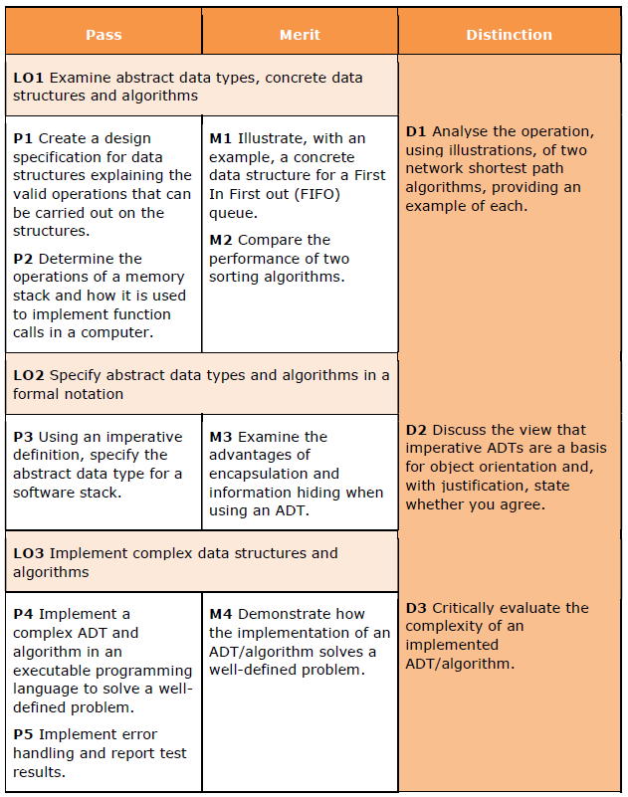

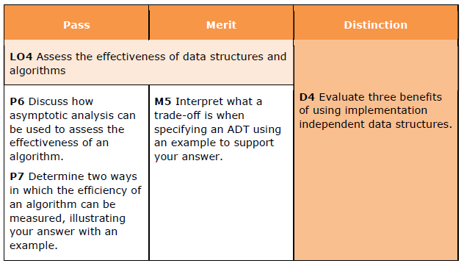

Scenario:

The knowledge to implement algorithms and data structures that solve real problems, and knowing the purpose, complexity and use of algorithms is part of an essential toolkit for software engineers.

An algorithm is a sequence of instructions used to manipulate data held in a structured form and together constitute design patterns for solving a diverse range of computer problems, including network analysis, cryptography, data compression and process control.

This assignment expects the students to understand the phenomena of data structures and how they are used in algorithms, enabling them to design and implement data structures. The unit introduces the specification of abstract data types and explores their use in concrete data structures. Based on this knowledge, students should be able to develop solutions by specifying, designing and implementing data structures and algorithms in a variety of programming paradigms for an identified need.

Among the topics included in this unit are abstract data types specification, formal data notations, data encapsulation, complex data structures, programming language implementations using handles, pointers, classes and methods, algorithm types, data structure libraries, algorithm complexity, asymptotic testing and benchmarking.

On completion of this assessment the student should be able to identify program data requirements, specify abstract data types using a formal notation, translate into concrete data structures and be able to develop, using a programming paradigm, different sorting, searching and navigational algorithms that implement complex data structures and evaluate their effectiveness.

As a result of studying this unit students will develop skills such as communication literacy, critical thinking, analysis, synthesis, reasoning and interpretation, which are crucial for gaining employment and developing academic competence.

Tasks

PART 1

Task 1.1

- You will need to prepare a report on how to create a design specification for data structures, explaining the valid operations that can be carried out on the structures using the example of:
ADTs such as Stack, Queue, Linear list and Binary tree.

- You will also need to illustrate, with an example, a concrete data structure for a First In First out (FIFO) queue.

- Prepare a brief documentary on how to determine the operations of a memory stack and how it is used to implement function calls in a computer.
Task 1.2

62 | 09 | 45 | 17 | 33 | 56 | 24 | 41

You will have to show the sorting methodologies for the above array in step by step process for the following sorting algorithms separately with clear explanations.
- Bubble sort
- Insertion sort
- Selection sort
- Quick sort

You are asked to compare the performance of Bubble sort and Quick sort with the help of above done sorting processes.

Task 1.3

Show how to analyze the operation, using illustrations, of the below given two network shortest path algorithms, providing an example of each.
1. Dijkstra’s algorithm
2. Bellman – Ford algorithm

Part 2

Task 2

You will need to provide a formal written report that includes the following:
1. Explanation on how to specify an abstract data type using the example of software stack.
2. Explanation of the advantages of encapsulation and information hiding when using an ADT.
3. Discussion of imperative ADTs with regard to object orientation.

Part 3
Task 3

You are requested to do the following tasks for any of well-known ADTs (eg: stack, queue, etc.) and any of familiar sorting algorithms.
- How to implement a complex ADT and algorithm in an executable programming language to solve a well-defined problem?
- How would you demonstrate how the implementation of the ADT/algorithm solves a well-defined problem?
- Show how to critically evaluate the complexity of the implemented ADT/algorithm.
- Define how to Implement error handling and report test results.

Part 4

Task 4
When we are talking about Usage of data structure libraries (DSL), we can mainly define two analysis methods such that theoretical analysis and asymptotic analysis. Answer the following questions.
- Briefly discuss how asymptotic analysis can be used to assess the effectiveness of an algorithm.
- Clearly interpret what a trade-off is when specifying an ADT using an example to support your answer.
- Provide an evaluation on three benefits of using implementation independent data structures.
- Precisely determine two ways in which the efficiency of an algorithm can be measured, illustrating your answer with an example.

NOTE:

- This assessment brief should be attached with your answers when you submit your final report.
- If the assignment is submitted after the extended deadline, the assignment will not be accepted whereas you shall be asked to go for a NEW assignment.

Instructions to students:
- All assignment should comprise of the standard Front page given. No other front page will be accepted.
- All assignment should be bound with transparent board as the front cover and BLACK hard board cover as the last sheet.
- Clearly label the CDs with your Name, Batch No. and Student NO and attach it to the back cover of your assignment.
- Report Writing Guidelines:
- Every Assignment should have an Introduction and Conclusion.
- The standard Table of Contents should be generated.
- All the Figures, Tables, Diagram etc. should be numbered.
- Main Heading: Font: Arial; Size 16
- Sub heading: Font: Arial; Size 14
- Body text: Font: Arial; Size 11
- Paragraph: Single line
- Margins: Top: 1” Bottom: 1” Left: 1” Right: 1”
- Header – include the module name on the right-hand side
- Footer – include the page number on the right-hand side
- All sections should have continuity and pages should be clearly ladled.
- References – clear references for all the materials, books, articles, website etc. should be given in the following format:
- Books – Title, Author, ISBN No, Publisher & Edition, Chapter & Page Nos.
- URL: Complete address e.g. http://www.abs.com/index/1234/xyz/.asp. and Date
- Article, Journals: Name of published material, Date, Author

